**ASSIGNMENT NO. 03**

**Name – Atharva Shivaji Jadhav Roll Number - DXC262AB12035**

**Batch – Dxc-262-Analytics-B12-Azure Company – DXC Technology**

**Employee Domain –Azure Analytics Training Under – Manipal Pro Learn**

**Trainer Name – Mr. Ajay Kumar No.Of Cases: 12**

**Case 21:**

**From the following table, write a SQL query to find those employees whose**

**experience is more than 27 years. Return complete information about the**

**employees.**

**Query:**

**SELECT \***

**FROM GLOBETECHTB231**

**WHERE ((MONTHS_BETWEEN(SYSDATE,HIRE_DATE))/12)>27;**

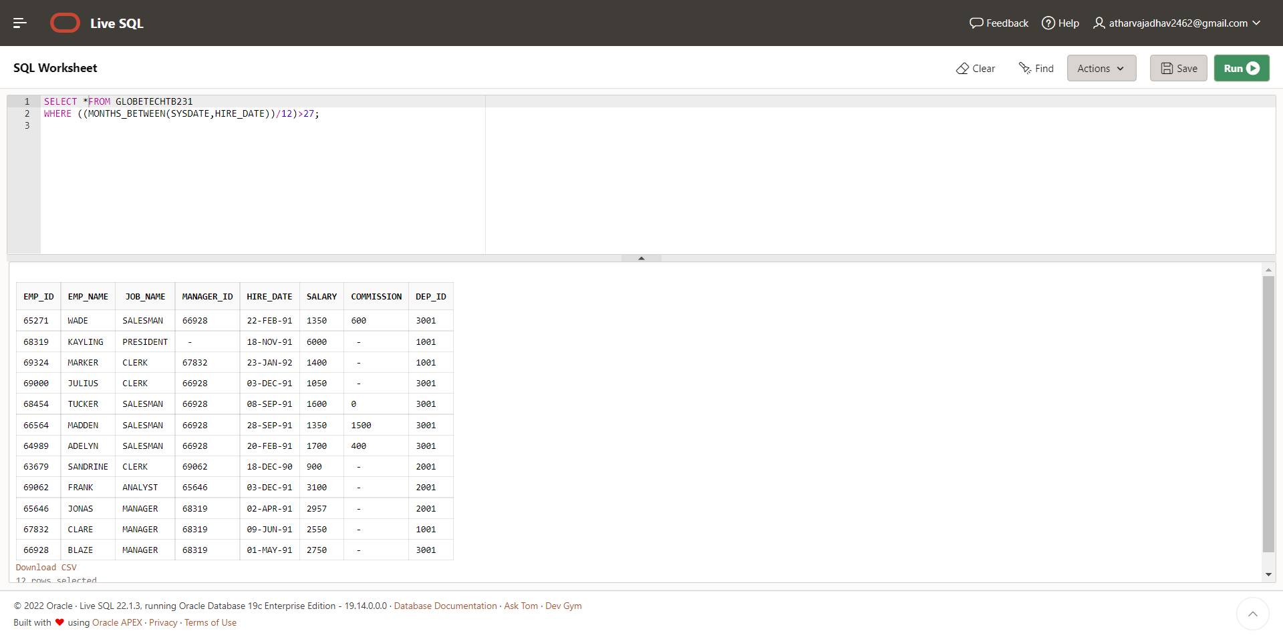

**Case 22:**

**From the following table, write a SQL query to find those employees whose**

**salaries are less than 3500. Return complete information about the employees.**

**Query:**

**SELECT \***

**FROM globetechtb231**

**WHERE salary <3500;** 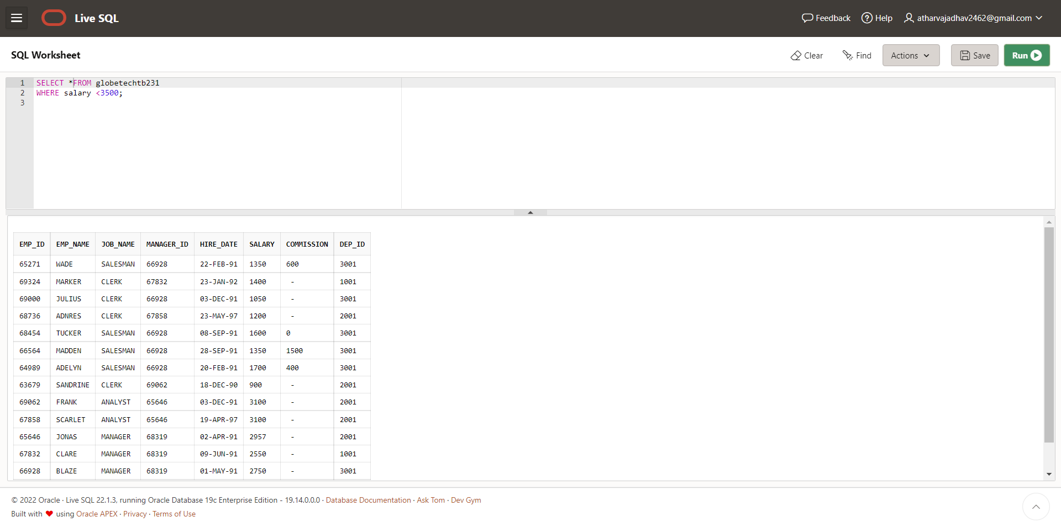

**Case 23:**

**From the following table, write a SQL query to find the employee whose**

**designation is ‘ANALYST’. Return employee name, job name and salary.**

**Query:**

**SELECT emp_name,**

**job_name,**

**salary**

**FROM globetechtb231**

**WHERE job_name = 'ANALYST';** 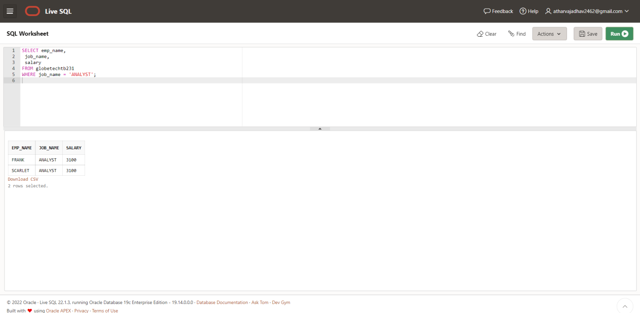

**Case 24:**

**From the following table, write a SQL query to find those employees who have**

**joined in the year 1991.Return complete information about the employees.**

**Query:**

**SELECT \***

**FROM globetechtb231**

**WHERE to_char(hire_date,'YYYY') = '1991';** 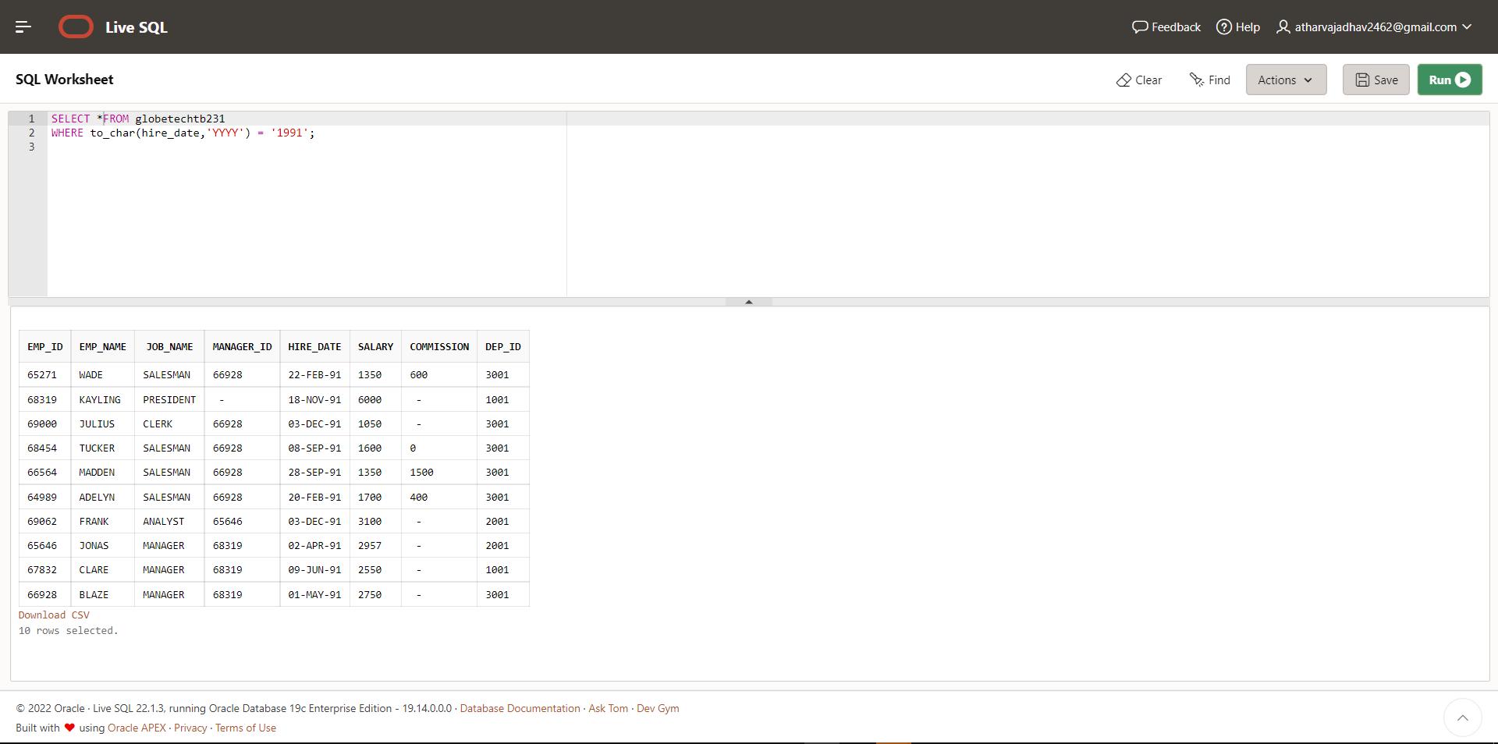

**Case 25:**

**From the following table, write a SQL query to find those employees who**

**joined before 1st April 1991. Return employee ID, employee name, hire date**

**and salary.**

**Query:**

**SELECT e.emp_id,**

**e.emp_name,**

**e.hire_date,**

**e.salary**

**FROM globetechtb231 e**

**WHERE hire_date <to_date('1991-04-01', 'YYYY-MM-DD');** 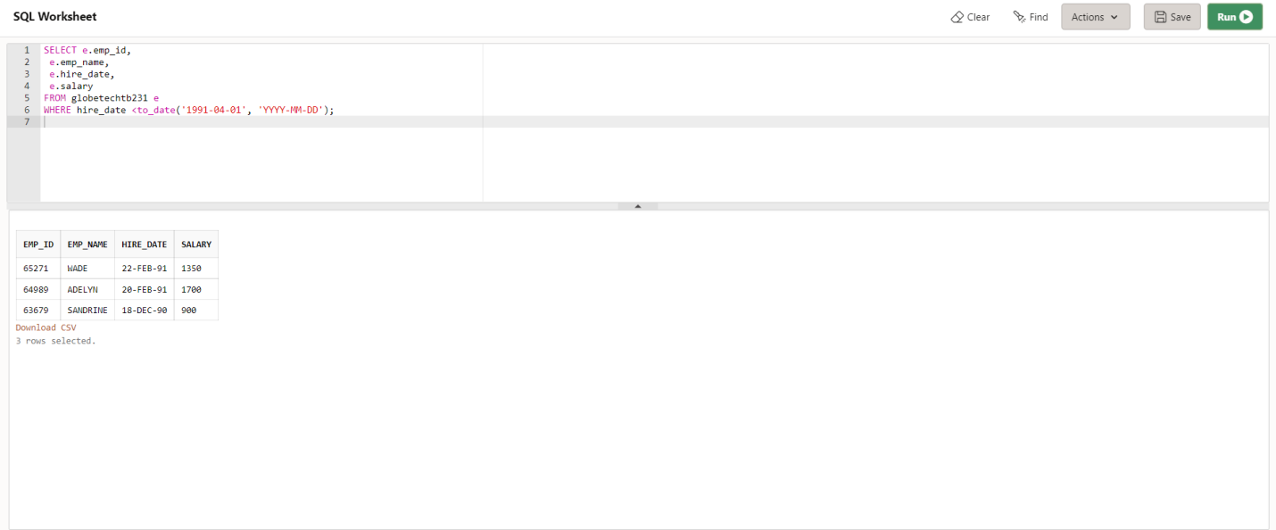

**Case 26:**

**From the following table, write a SQL query to find those employees who are**

**not working under a manager. Return employee name, job name.**

**Query:**

**SELECT e.emp_name,**

**e.job_name**

**FROM globetechtb231 e**

**WHERE manager_id IS NULL;**

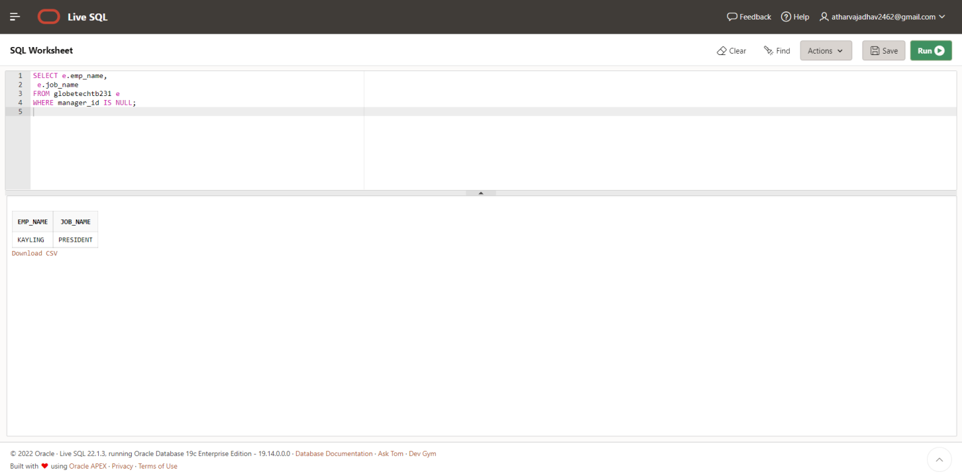

**Case 27:**

**From the following table, write a SQL query to find those employees who**

**joined on 1st May 91. Return complete information about the employees.**

**Query:**

**SELECT \***

**FROM globetechtb231**

**WHERE hire_date = to_date('1991-05-01','yyyy-mm-dd');** 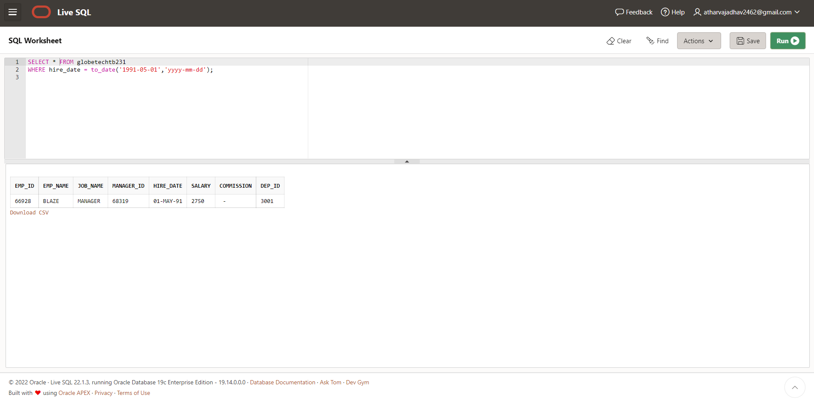

**Case 28:**

**From the following table, write a SQL query to find those employees working**

**under the manger whose ID is 68319. Return employee ID, employee name,**

**salary, and age.**

**Query:**

**SELECT emp_id,**

**emp_name,**

**salary,**

**ROUND(months_between(sysdate, hire_date)/12) "Experience"**

**FROM globetechtb231**

**WHERE manager_id=68319;** 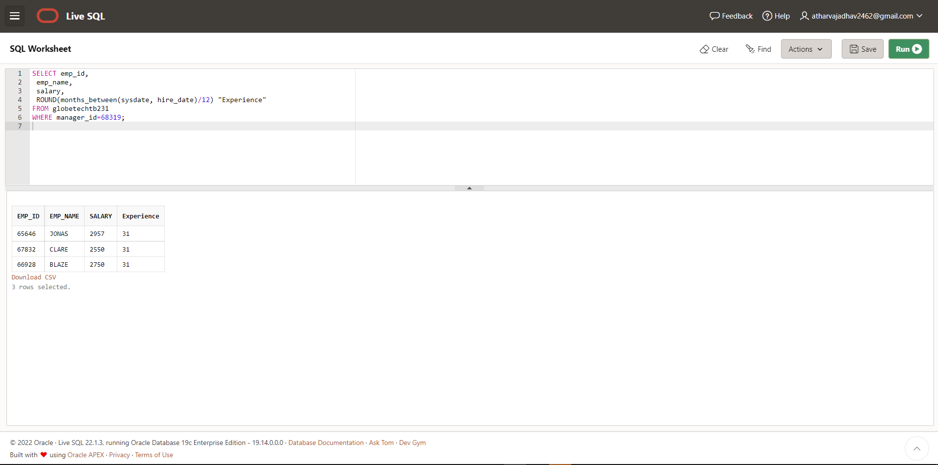

**Case 29:**

**From the following table, write a SQL query to find those employees who earn**

**more than 100 as daily salary. Return employee ID, employee name, salary,**

**and age.**

**Query:**

**SELECT emp_id,**

**emp_name,**

**salary,**

**ROUND(months_between(sysdate, hire_date)/12) "Experience"**

**FROM globetechtb231**

**WHERE (salary/30)>100;** 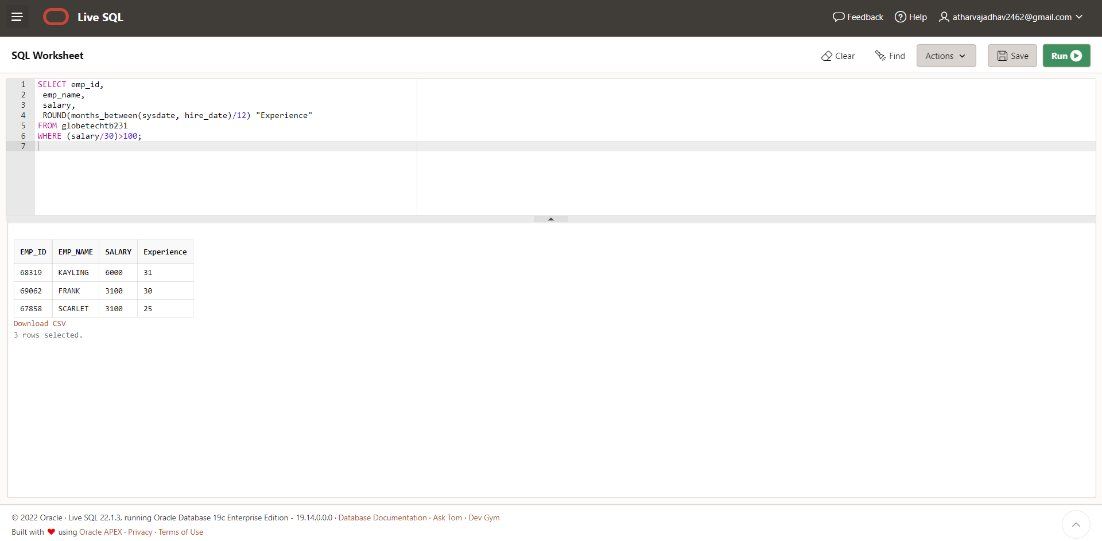

**Case 30:**

**From the following table, write a SQL query to find those employees who**

**retired after 31-Dec-99, completion of 8 years of service period. Return**

**employee name.**

**Query:**

**select emp_name from globetechtb231 where hire_date>to_date('1992-01-**

**01','YYYY-MM-DD');** 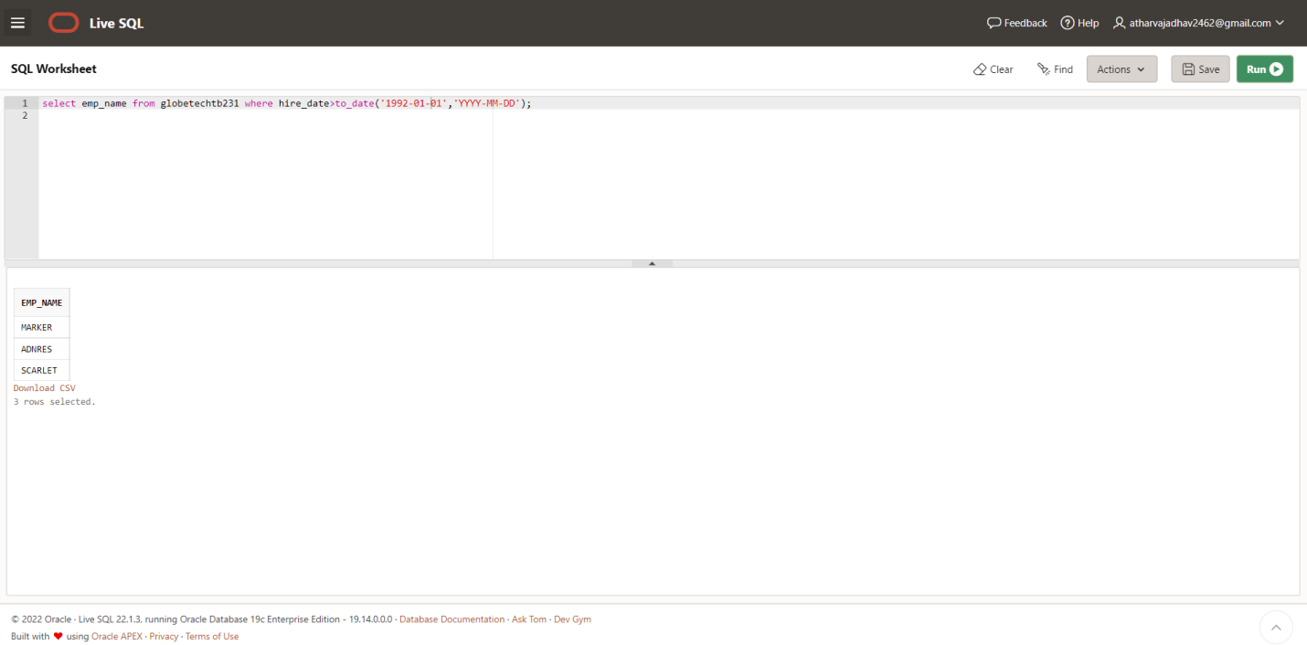

**Case 31:**

**From the following table, write a SQL query to find those employees whose**

**salary is an odd value. Return complete information about the employees.**

**Query:**

**SELECT \***

**FROM globetechtb231**

**WHERE mod(salary,2) = 1;** 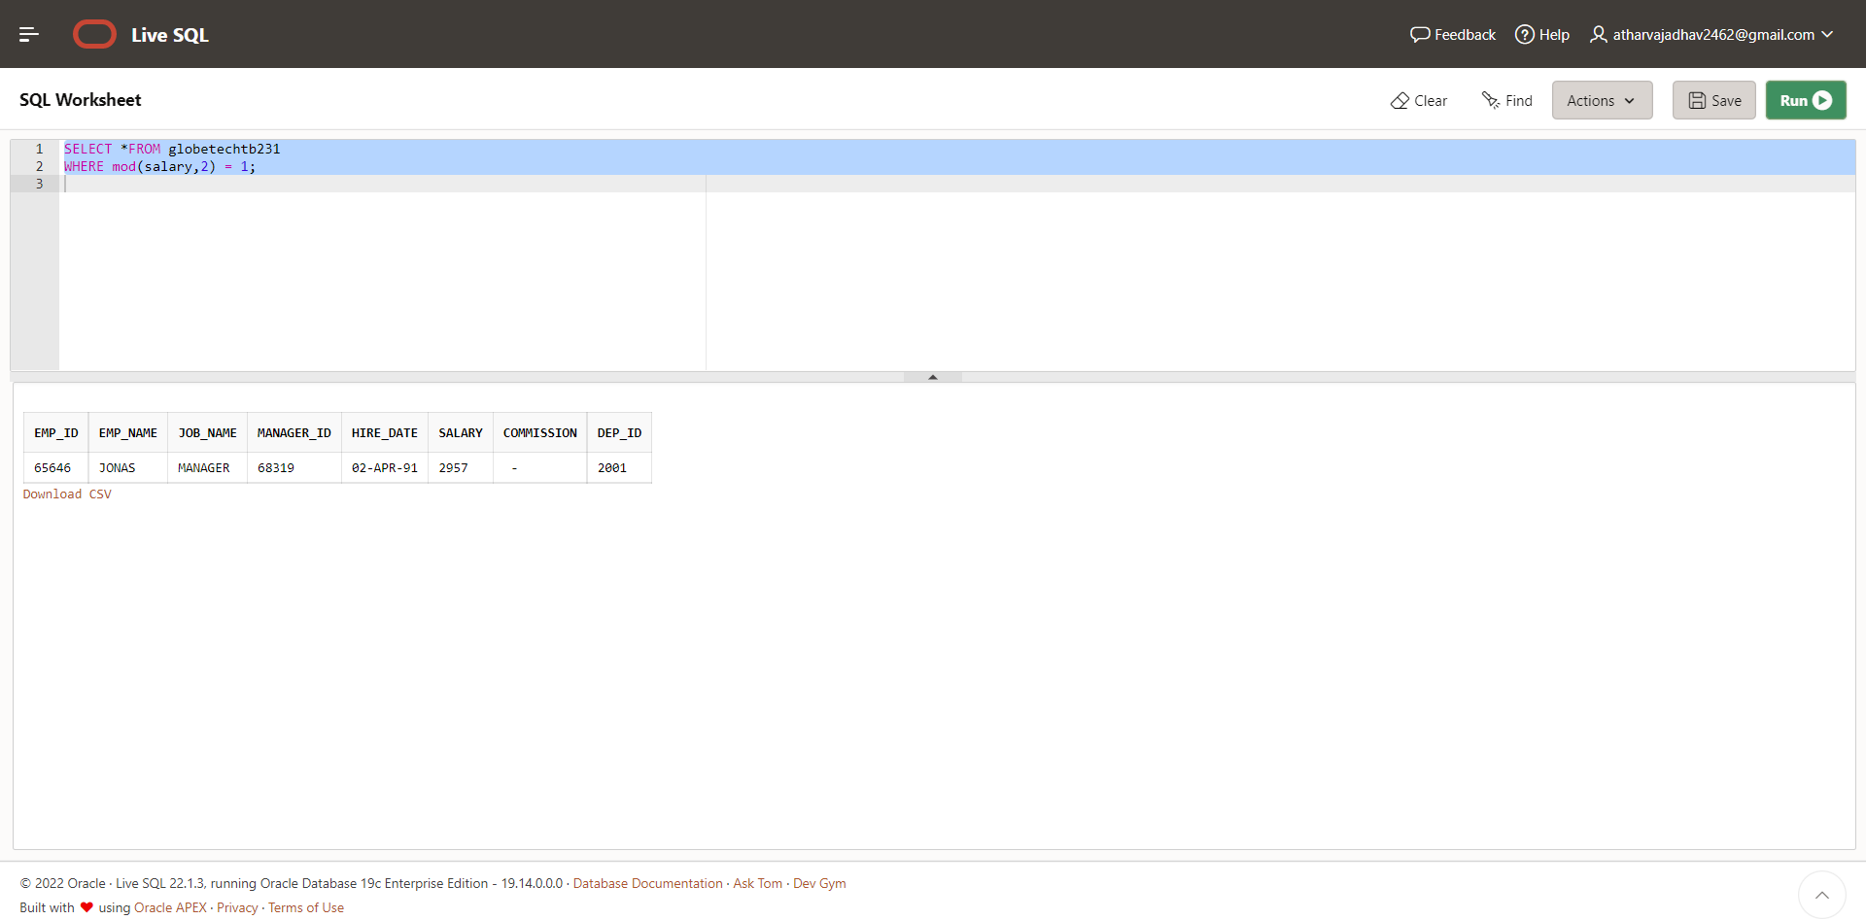

**Case 32:**

**From the following table, write a SQL query to find those employees whose**

**salaries are less than 3500. Return complete information about the employees.**

**Query:**

**SELECT \***

**FROM globetechtb231**

**WHERE length(TRIM(TO_CHAR(salary,'9999'))) = 3;** 